**Histogram Specification**

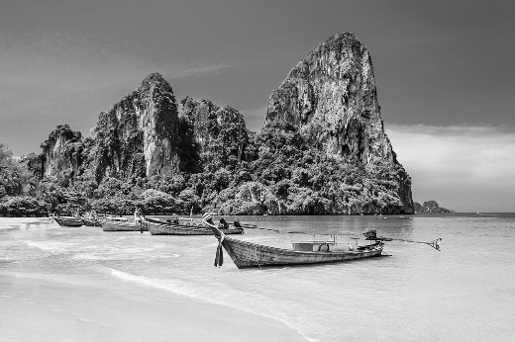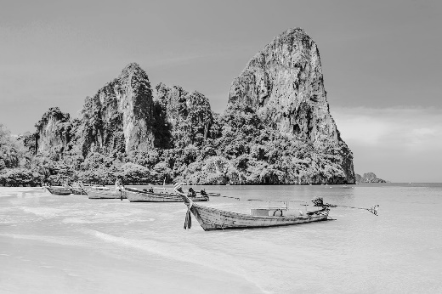

**Fig. 1** Target Image

**Fig. 2** Input Image

**Fig. 3** Output Image

**Fig. 1** Target Image

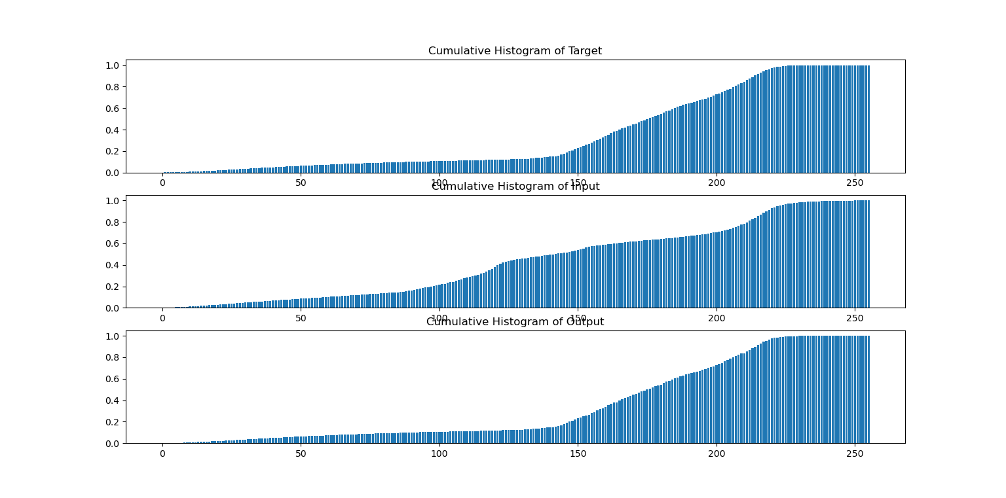

**Fig. 4** Cumulative Histogram of three images

**Fig. 5** Histogram of three images

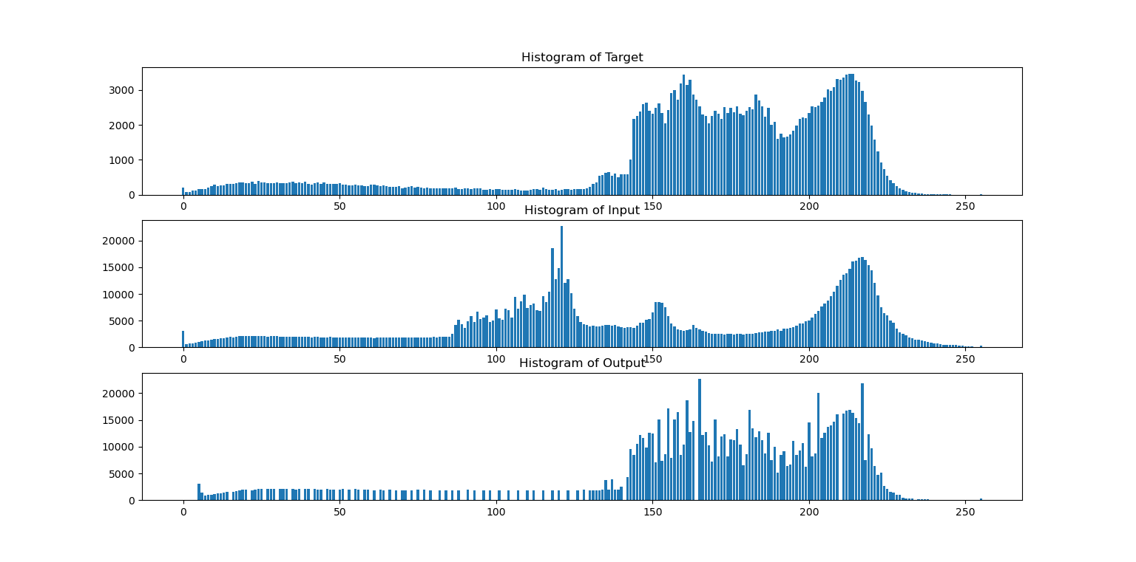

Spike

Gap

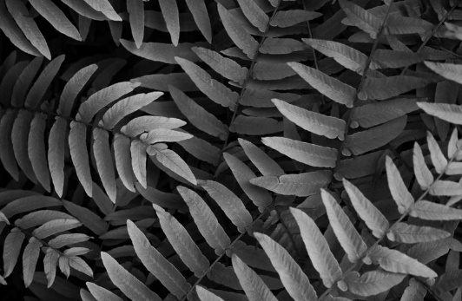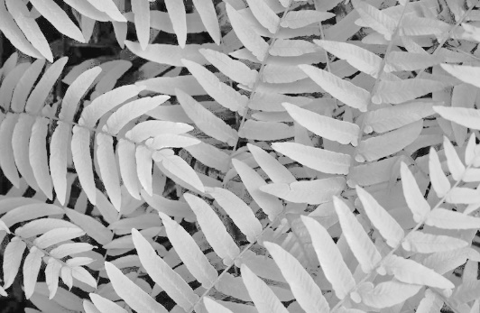

**Fig. 6** Target Image

**Fig. 7** Input Image

**Fig. 8** Output Image

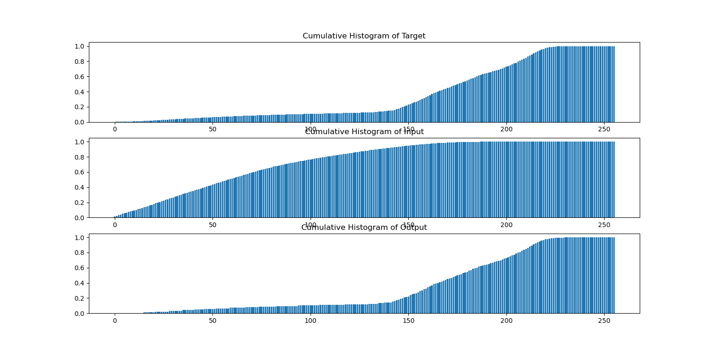

**Fig. 9** Cumulative Histogram of three images

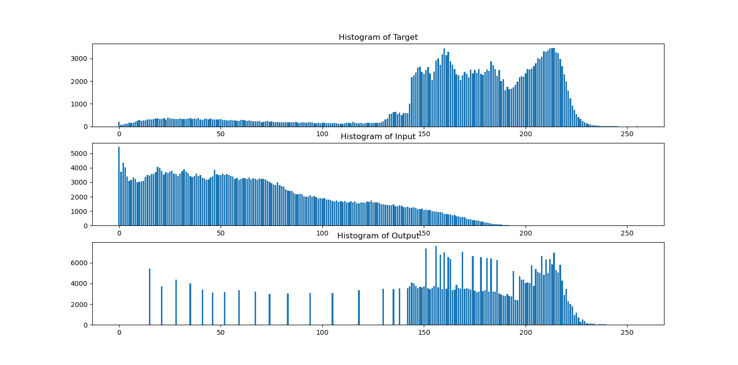

Spike

Gap

**Fig. 10** Histogram of three images